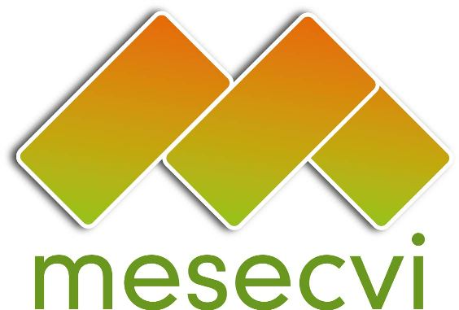
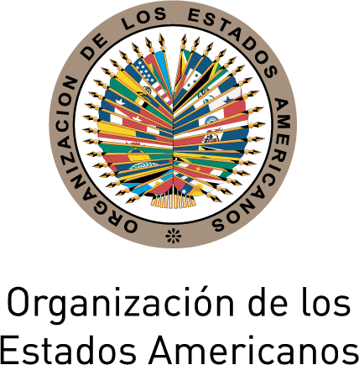

FOLLOW-UP MECHANISM TO THE OEA/Ser.L/II.7.10
BELÉM DO PARÁ CONVENTION (MESECVI) MESECVI/CEVI/doc.223/15
Twelfth Meeting of the Committee of Experts October 5th, 2015
October 13th-14th, 2015 Original: español
Lima, Perú

GUIDELINES TO PROCESS THE REQUEST FOR TECHINCAL ASSISTANCE AND COMMUNICATIONS EMMANAITING FROM THE CEVI
(Draft)

  Challenges in the implementation of the Convention |  | Progress in the implementation of the Convention

- President of the CEP
- President of the CEVI
- Committee of Experts
- Competent National Authorities
- Non-governmental organizations registered with the OAS
A letter is issued, recognizing the progress made by the State

A communication is sent to the Technical Secretariat of the MESECVI
President and two Vice-presidents of the Committee of Experts

Issue a letter addressed to the State Party, with recommendations, in accordance with its international obligations on women’s human rights |  | If requested by the State Party, an Expert/s of the Committe is sent to provide technical assitance |  | Amicus Curiae |  | Establish coordination meetings on the Convention of Belém do Pará

The Technical Secretariat will follow-up and report to the Committee of Experts

